Bowen Jiang (NUID: 001582174)

INFO 6205

Program Structures & Algorithms

Fall 2020

Assignment 3

Task: Your task is

Step 1:  
(a) Implement height-weighted Quick Union with Path Compression. For this, you will flesh out the class UF_HWQUPC. All you have to do is to fill in the sections marked with // TO BE IMPLEMENTED ... // ...END IMPLEMENTATION.

(b) Check that the unit tests for this class all work. You must show "green" test results in your submission

Step 2:  
Using your implementation of UF_HWQUPC, develop a UF ("union-find") client that takes an integer value n from the command line to determine the number of "sites." Then generates random pairs of integers between 0 and n-1, calling connected() to determine if they are connected and union() if not. Loop until all sites are connected then print the number of connections generated. Package your program as a static method count() that takes n as the argument and returns the number of connections; and a main() that takes n from the command line, calls count() and prints the returned value. If you prefer, you can create a main program that doesn't require any input and runs the experiment for a fixed set of n values. Show evidence of your run(s).

Step 3:  
Determine the relationship between the number of objects (*n*) and the number of pairs (*m*) generated to accomplish this (i.e. to reduce the number of components from *n* to 1). Justify your conclusion. Don't forget to follow the submission guidelines. And to use sufficient (and sufficiently large) different values of n.

**Output**

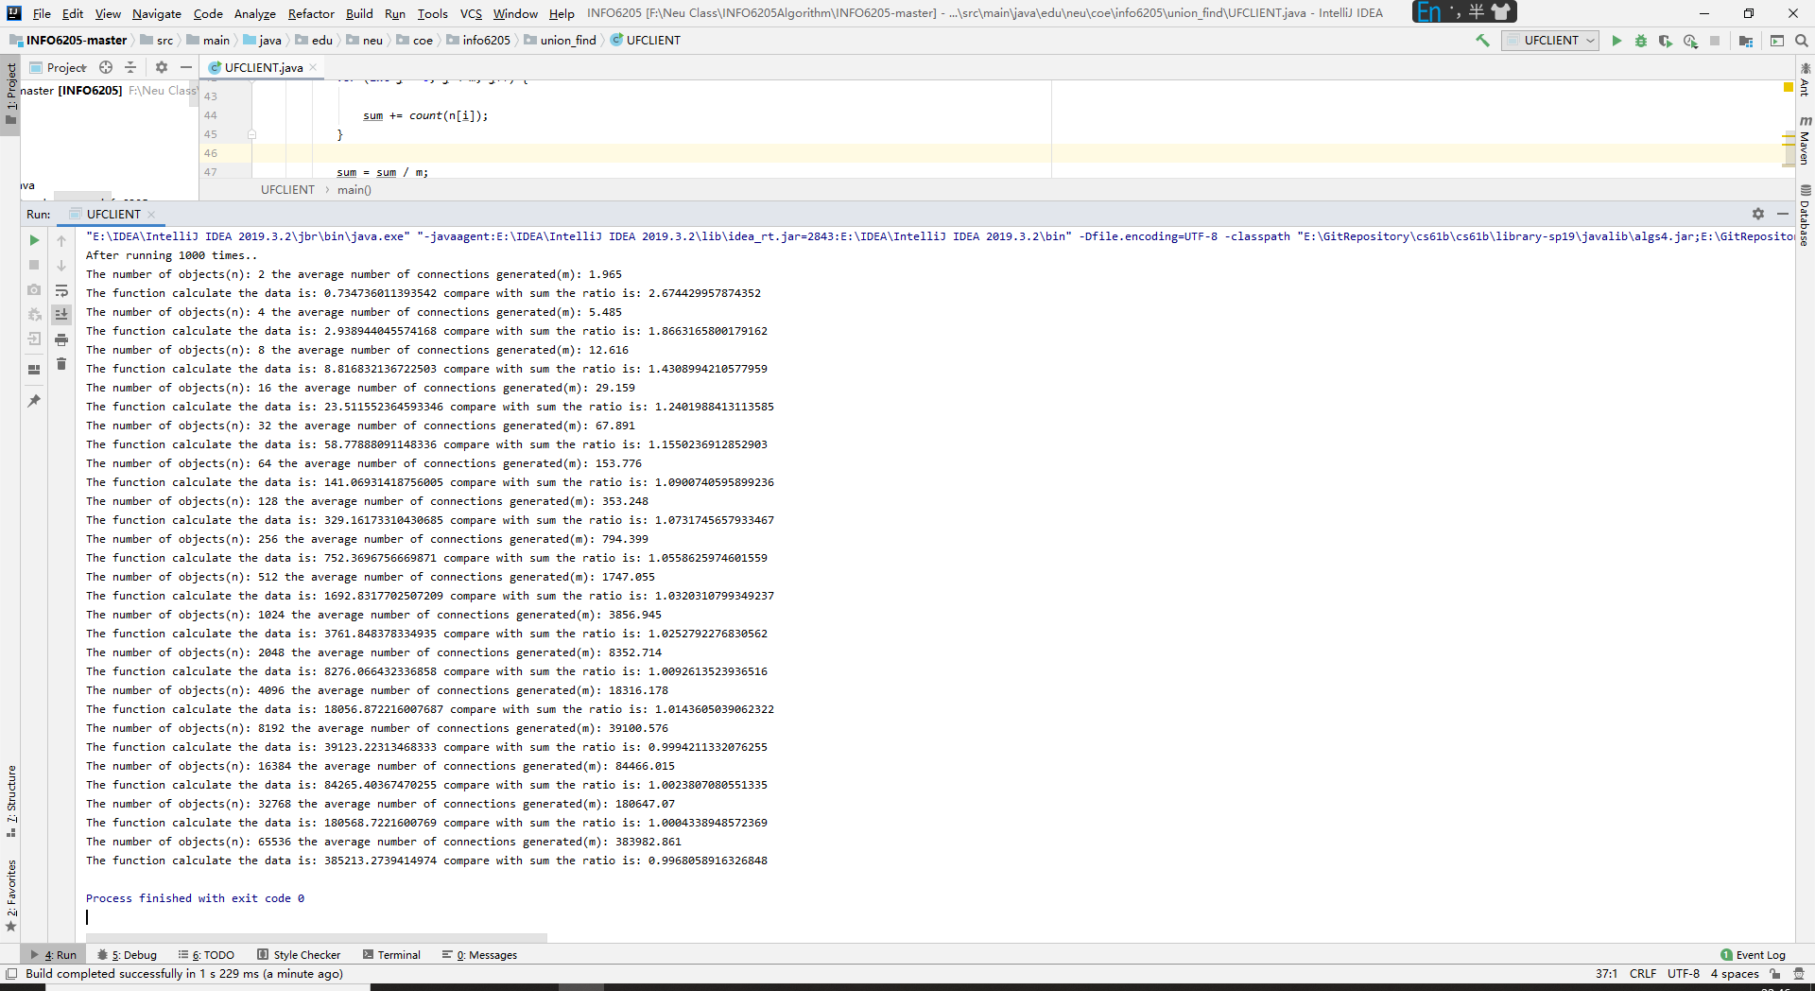

**Relationship Conclusion**

The relationship between the number of objects (*n*) and the number of pairs (*m*)：

m = 0.53nlogn

To demonstrate this function, I calculate the ratio between the experimental data sum / m.

And the ratio tends to 1.0 show that the formula is true.

**Evidence to support relationship**

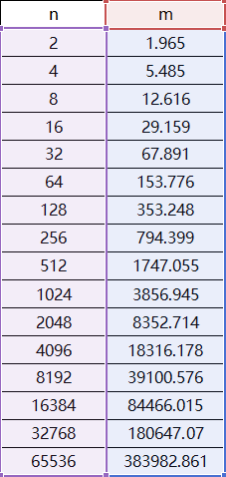 This Table shows the experimental data.

And I use a scatter diagram to analyze the relationship between the number of objects (*n*) and the number of pairs (*m*).

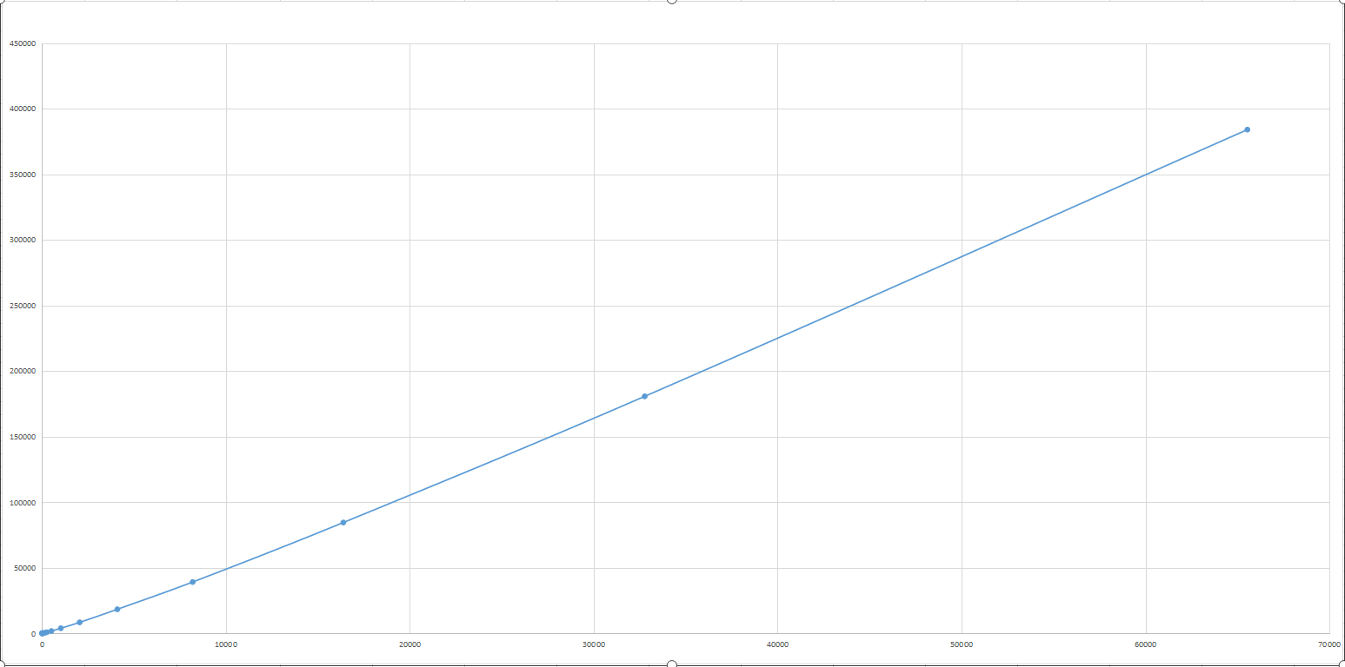

**Screenshot of Unit test passing**

UF_HWQUPC_Test.java

